**Traffic Manger Profile**

1. Created Traffic Manager Profiles with name **AnnuTM** having Routing method as Performance in **Annurg** Resource group.

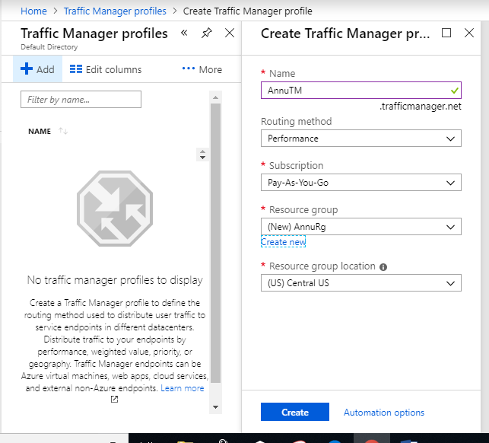

1. Adding Endpoints with name **AnnuEpPerf** in Traffic Manager Profile

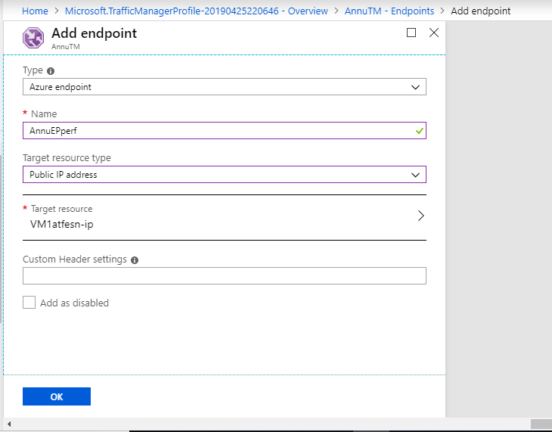

1. Created Traffic Manager Profiles with name **AnnutmPrio** having Routing method as Priority in **Annurg** Resource group.

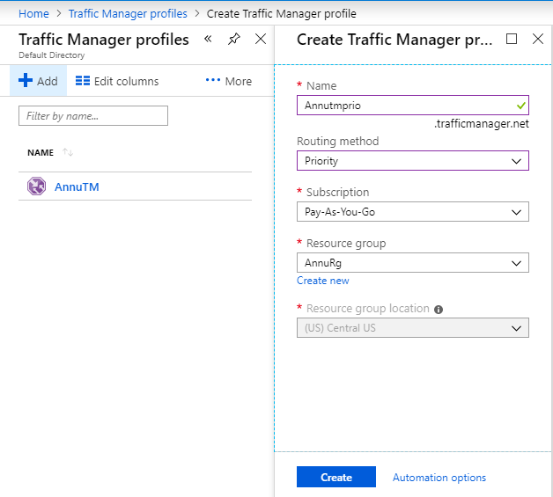

1. Adding Endpoints with name **AnnuEpPrio** in Traffic Manager Profile

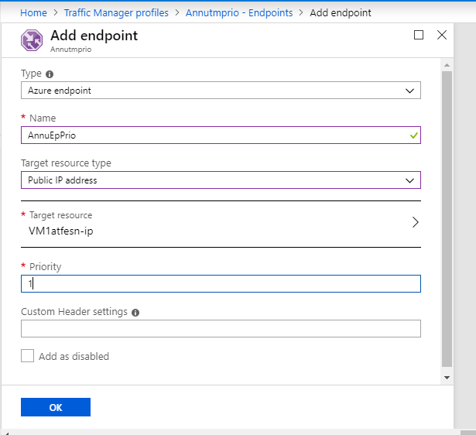

1. Created Traffic Manager Profiles with name **AnnutmWeig** having Routing method as Weighted in **Annurg** Resource group.

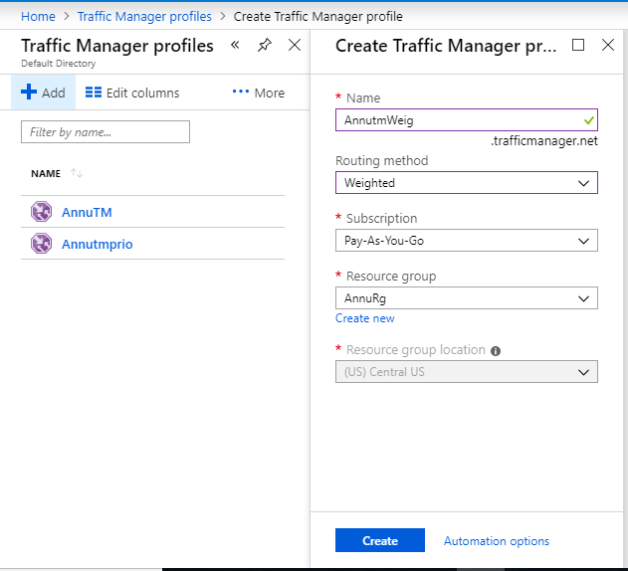

1. Adding Endpoints with name AnnuEpWeig in Traffic Manager Profile

